What are Wordpress plugins

What are plugins in Wordpress, what can the be used for, how to find them and install them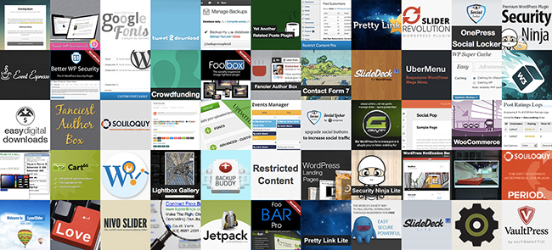

## Prepare a presentation

You will have to prepare a presentation (media of your choice) where you answer the following questions about Wordpress plugins.

What are plugins in Wordpress?

How do you find a plugin online?

How do you install a plugin?

Which folder are the plugins installed in?

[Optional] Install a plugin and show how you did it

[Optional] What is WooCommerce

You are free to use any resource you see fit.

The following are just suggestions to get you started:

<https://codex.wordpress.org/Plugins>

<http://www.wpbeginner.com/glossary/plugin/>

<http://www.wpexplorer.com/using-wordpress-plugins/>

<https://www.youtube.com/watch?v=mmpoAC9HhRQ>

<http://www.wpbeginner.com/category/plugins/>